**2.0 User Scenario:**

This section provides a usage scenario for the software. It organizes information collected during requirements elicitation into use-cases.

**2.1 User profiles:**

**Staff**

The staff has been authorized to access into database. He/She can update and modify the library database about total available books and total checked book. Staff can add/update/delete all information is required. He/she can generate many useful reports, such as user information, account access level and order lists.

**Students/Parents**

Students and parents have only some authorizations of the application. Students can create their own account by using Email address and then share their account to their parents. Students also can place book orders, cancel orders and query order status which means showing due dates. Students and parents do not have any abilities to change the system.

**Teacher**

Teacher have the same abilities with students and teacher can check out books by class. At the same time, teachers also cannot change the system.

**2.2 Use-cases**

All use-cases for the software are presented.

2.2.1 Staff use case:

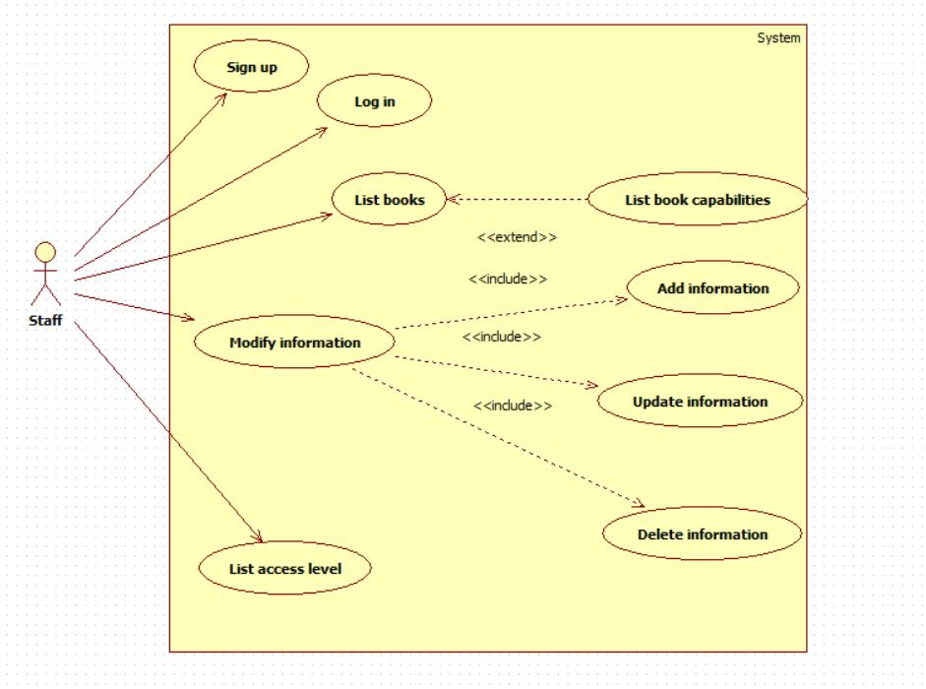

Table 2.2.1.1 “Sign up” use case description

|  |  |
| --- | --- |
| Name: | Sign up |
| Actor: | Staff |
| Description: | Staff register account information |
| Main Course: | Main course:  1）The user clicks the "Register" button on the login interface;  2）The system go to "registration" interface;  3）The user in the "registration" interface for user information input, 包括手机号，昵称，密码，密保问题，密保答案，邮箱，性别，出生年月等信息，When finished, click the "Register" button;  4）The system is driven by the "Register" button event, adds the user registration information to the database, and then displays the prompt window "Register successful" to the user. |
| 前置条件： | 用户成功进入注册界面 |

Table 2.2.1.2 “Log in” use case description

|  |  |
| --- | --- |
| Name: | Log in |
| Actor: | Staff |
| Description: | Staff log in account |
| Precondition: | User enter login interface successfully |
| Main Course: | Main course:  1) Users in the login interface to fill out the account number, password and other information, click on the login button;  2) The system is driven by the event of the button, converted to "home_staff" interface. |
| Alternate course: | AC1: If staff forget their password.   1. The user can click the "Forgot Password" button. |

Table 2.2.1.3 “List books” use case description

|  |  |
| --- | --- |
| Name: | List books |
| Actor: | Staff |
| Description: | List books information |
| Precondition: | User enter staff main interface successfully |
| Main Course: | Main course:  1) Users in the main interface to click on the list books information button;  2) The system is driven by the event of the button, showing books information  3) The system shows capabilities information, such as total number, total check out and available number from database. |

Table 2.2.1.4 “Modify information” use case description

|  |  |
| --- | --- |
| Name: | Modify information |
| Actor: | Staff |
| Description: | Modify information from database |
| Precondition: | User enter staff main interface successfully |
| Main Course: | Main course:  1) Users in the main interface to click on the modify information button;  2) The system is driven by the event of the button, showing books’ information  3) The user can add, update, and delete information |

Table 2.2.1.5 “List access level” use case description

|  |  |
| --- | --- |
| Name: | List access level |
| Actor: | Staff |
| Description: | List all users’ access level |
| Precondition: | User enter staff main interface successfully |
| Main Course: | Main course:  1) Users in the main interface to click on the list access information button;  2) The system is driven by the event of the button, showing all users’ access level. |

2.2.2 Students/Parents use case

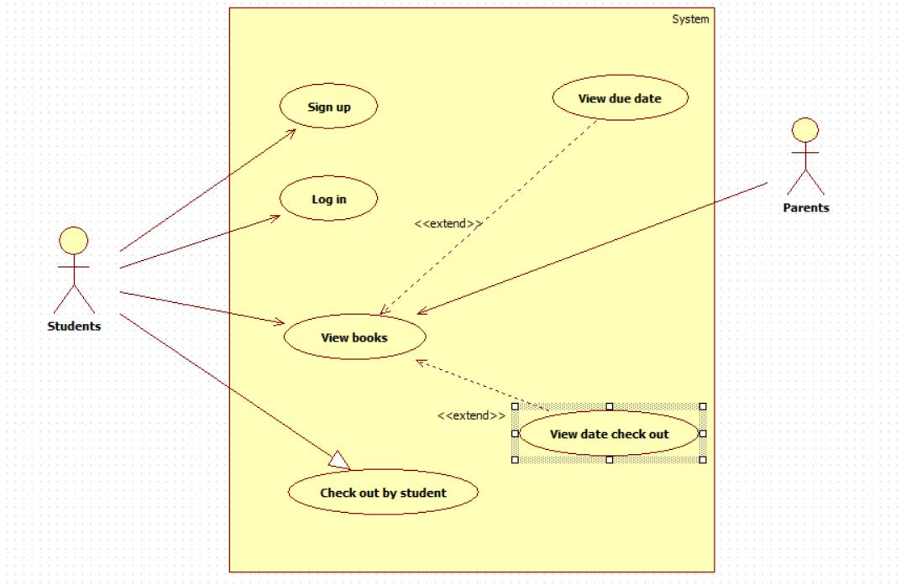

Table 2.2.2.1 “Sign up” use case description

|  |  |
| --- | --- |
| Name: | Sign up |
| Actor: | Students / Parents |
| Description: | Students register account information |
| Main Course: | Main course:  1）The user clicks the "Register" button on the login interface;  2）The system go to "registration" interface;  3）The user in the "registration" interface for user information input, 包括手机号，昵称，密码，密保问题，密保答案，邮箱，性别，出生年月等信息，When finished, click the "Register" button;  4）The system is driven by the "Register" button event, adds the user registration information to the database, and then displays the prompt window "Register successful" to the user. |
| 前置条件： | 用户成功进入注册界面 |

Table 2.2.2.2 “Log in” use case description

|  |  |
| --- | --- |
| Name: | Log in |
| Actor: | Students / Parents |
| Description: | students log in account |
| Precondition: | User enter login interface successfully |
| Main Course: | Main course:  1) Users in the login interface to fill out the account number, password and other information, click on the login button;  2) The system is driven by the event of the button, converted to "home" interface. |
| Alternate course: | AC1: If staff forget their password.   1. The user can click the "Forgot Password" button. |

Table 2.2.2.3 “View books” use case description

|  |  |
| --- | --- |
| Name: | Log in |
| Actor: | Students / Parents |
| Description: | User view books’ information |
| Precondition: | User enter login interface successfully |
| Main Course: | Main course:  1) Users in the main interface to click on the view books button;  2) The system is driven by the event of the button, showing books information |
| Alternate course: | AC1: The user enter view books interface   1. The user can view the "due date" of borrowed books 2. The use can make an operation called “view date check out” |

Table 2.2.2.4 “Check out by students” use case description

|  |  |
| --- | --- |
| Name: | Check out by students |
| Actor: | Students / Parents |
| Description: | User check out books |
| Precondition: | User enter login interface successfully |
| Main Course: | Main course:  1) Users in the main interface to click on the check out by students books button; |

2.2.3 Teachers use case

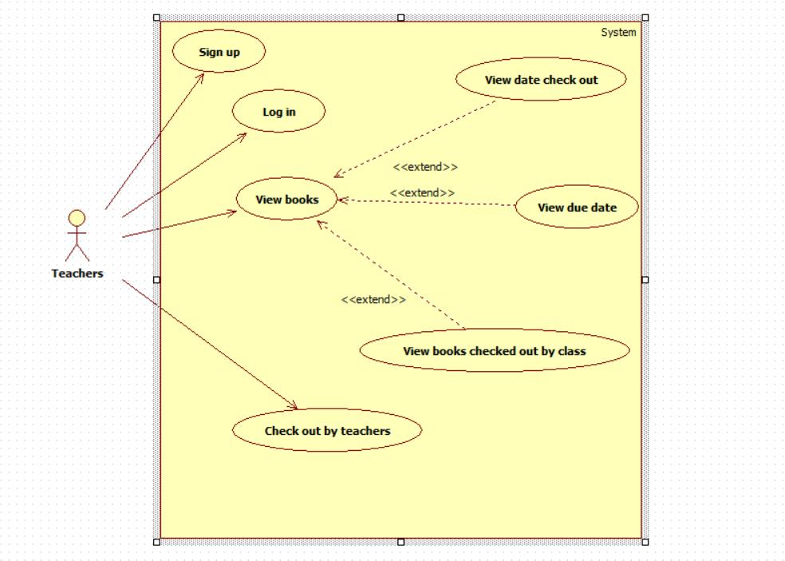

Table 2.2.3.1 “Sign up” use case description

|  |  |
| --- | --- |
| Name: | Sign up |
| Actor: | Teachers |
| Description: | Teachers register account information |
| Main Course: | Main course:  1）The user clicks the "Register" button on the login interface;  2）The system go to "registration" interface;  3）The user in the "registration" interface for user information input, 包括手机号，昵称，密码，密保问题，密保答案，邮箱，性别，出生年月等信息，When finished, click the "Register" button;  4）The system is driven by the "Register" button event, adds the user registration information to the database, and then displays the prompt window "Register successful" to the user. |
| 前置条件： | 用户成功进入注册界面 |

Table 2.2.3.2 “Log in” use case description

|  |  |
| --- | --- |
| Name: | Log in |
| Actor: | Teachers |
| Description: | Teachers log in account |
| Precondition: | User enter login interface successfully |
| Main Course: | Main course:  1) Users in the login interface to fill out the account number, password and other information, click on the login button;  2) The system is driven by the event of the button, converted to "home " interface. |
| Alternate course: | AC1: If staff forget their password.   1. The user can click the "Forgot Password" button. |

Table 2.2.3.3 “View books” use case description

|  |  |
| --- | --- |
| Name: | Log in |
| Actor: | Teachers |
| Description: | User view books’ information |
| Precondition: | User enter login interface successfully |
| Main Course: | Main course:  1) Users in the main interface to click on the view books button;  2) The system is driven by the event of the button, showing books information |
| Alternate course: | AC1: The user enters view books interface   1. The user can view the "due date" of borrowed books 2. The use can make an operation called “view date check out” 3. The use can make an operation called “view books check out by class” |

Table 2.2.3.4 “Check out by teachers” use case description

|  |  |
| --- | --- |
| Name: | Check out by teachers |
| Actor: | Teachers |
| Description: | User check out books |
| Precondition: | User enter login interface successfully |
| Main Course: | Main course:  1) Users in the main interface to click on the check out by teachers books button; |

**2.3 Special usage considerations:**

This is a web-based application, a standards compliant browser is essential.  
At a minimum, the application must work with Internet Explorer 5 and higher and browsers based Mozilla Firefox 1.5 and higher. The browsers must also support per-session cookies and visual basic script.